# Practical 2: Complexity Analysis

**Background**

When we study algorithms, we are interested in characterizing them according to their efficiency. We are interested in the order of growth of the running time of an algorithm, not in the exact running time. We call this the asymptotic running time. We need to develop a way to talk about the rate of growth of functions so that we can compare different algorithms. Asymptotic notation gives us such a method.

So if someone tells you that their algorithm runs in O(n³), then that means their code has n³ operations or less. For this very reason Big O notation is said to give you upper bounds on an algorithm’s performance. **Big O tells you that your algorithm is at least this fast or faster - it won’t run slower.**

In general, you would not say a function runs in Big O of n² if you can prove that it runs in Big O of n. If someone showed you the print Hello() function above, in an interview and asked you to find the complexity of it, if you answer O(n²), more than likely they would disqualify you. Even though it is technically correct, the answer they would expect is O(n).

**What am I doing today?**

Today’s practical focuses on 3 things:

1. Understanding the basic order of growth functions
2. Classifying several algorithms and code snippets in Big-O
3. Run two different Big-O algorithms that solve the same problem and compare performance

**Instructions**

Try all the questions. Ask for help from the demonstrators if you get stuck.

Solutions will be posted afterward.

**Grading: Remember if you complete the practical, add the code to your github repo which needs to be submitted at the end of the course for an extra 5%**

**\*\*Github classroom will be setup from Week3**

**>>Copy this doc into your own folder**

# Order of growth classifications

The following are some of the common complexity functions you will encounter:

* **Constant: O(k), for example O(1)**: independent of the size of the input n
* **Logarithmic: O(log n):** Always increases, but at a slower rate as n increases. Typically found where the algorithm can systematically ignore fractions of the input.
* **Linear: O(n):** as n increases, run time increases in proportion
* **Linearithmic (n log n)**: Combination of O(n) and O(log n)
* **Quadratic: Θ(n2 ):** As n doubles, run-time quadruples. • However, it is still polynomial, which we consider to be good.
* **Polynomial: Θ(nk )**
* **Exponential: Θ(kn)**; This class is pretty much as bad as it gets. Can be used only for small values of n in practice.

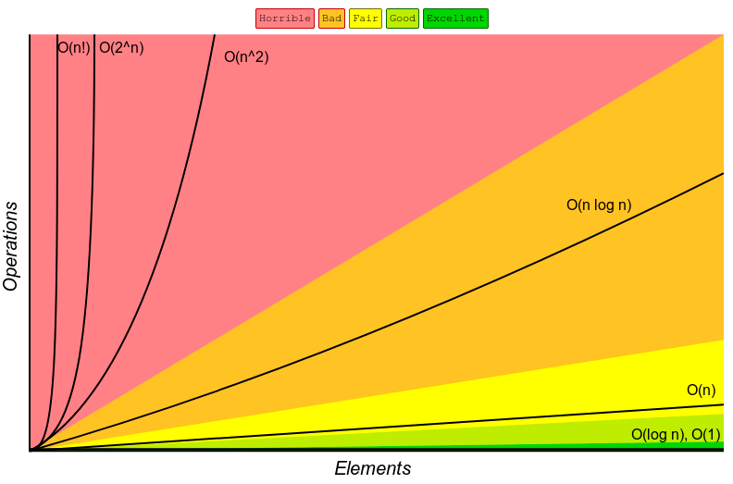

## Exercise 1: Complete these sentences..

1. Algorithms with time complexities such as n and 100n are called _____ algorithms.
2. Algorithms with time complexities such as n2 are called quadratic-time algorithms (True or False).
3. Any quadratic-time algorithm is eventually more efficient than any linear-time algorithm (True or False).
4. Functions such as 5n2 and 5n2 +100 are called _____ functions.

## 

## Exercise 2: Order of Growth Classifications

Rank the functions below according to their growth - marking 1 for the slowest growing functions (or fastest algorithm) to 7 for the fastest growing function (or slowest algorithm).

|  |  |
| --- | --- |
| T(N) | Growth function |
| n2 |  |
| 480 |  |
| 2n |  |
| logN |  |
| 24 |  |
| 380N |  |
| 1/2N |  |

Same thing:

|  |  |
| --- | --- |
| T(N) | Growth function |
| N logN |  |
| N4 |  |
| 2n |  |
| log8N |  |
| nlog4N |  |
| log2N |  |
| nlog6N |  |
| 300 |  |
| 6N3 |  |

*note: when speaking asymptotically, the base of logarithms is irrelevant. This is because of the identity loga b logb n = logan

## 

## Which kind of growth best characterizes each of the functions below?

|  |  |  |  |  |
| --- | --- | --- | --- | --- |
| **T(n)** | **Constant** | **Linear** | **Polynomial** | **Exponential** |
| **1** |  |  |  |  |
| **2n3** |  |  |  |  |
| **(4/3)n** |  |  |  |  |
| **2n** |  |  |  |  |
| **4n2** |  |  |  |  |
| **5600** |  |  |  |  |
| **2493n** |  |  |  |  |
| **3/2n** |  |  |  |  |

## 

## Simplify the following functions into their closest Big O growth factors

Remember the rules to find the asymptotic behavior of the following functions:

* Drop lower-order terms
* Drop constant factors
* Keep the terms that grow the fastest.
* Use the smallest possible class of functions

**Examples:**

Say “2n is O(n)” instead of “2n is O(n2)”

Say “3n + 5 is O(n)” instead of “3n + 5 is O(3n)

f( n ) = 5n + 12 => O(n)

**Try these ones yourself:**

1. f( n ) = 5n + 12
2. f( n ) = 109
3. f( n ) = n2+ 3n + 112
4. f( n ) = n3 + 1999n + 1337

## 

## Rules for classifying functions

**For Loop:** The running time of a for loop is at most the running time of the statements inside the loop times the number of loops

|  |  |
| --- | --- |
| for (int I = 0; I < n; i++){  doSomething();  } | **O(n)** |

**Nested loops:** Do the analysis inside out. The total running time of a statement inside a group of nested loops is the running time of the statement times the product of the sizes of all the loops

|  |  |
| --- | --- |
| for (int i = 0; i < n; i++){  For (int j = 0; j <n; j++){  doSomething();  }  } | **O(n2)** |

**Consecutive Statements / Functions**

These simply add - the maximum is the one that counts.

|  |  |
| --- | --- |
| for (int I = 0; I < n; i++){  doSomething();}  for (int i = 0; i < n; i++){  For (int j = 0; j <n; j++){  doSomething();  } } | **O(n)**  **O(n2)**  **T(N) = Total = O(n) + O(n2) = O(n2)** |

## 

## What is the complexity of the functions below?

|  |
| --- |
| int sum = 0; for (int i = 1; i < N; i *= 2)  for (int j = 0; j < N; j++)  sum++; |

|  |
| --- |
| function isEven(value){ if (value % 2 == 0){ return true; } else return false; } |

|  |
| --- |
| arrayMax(A, n) { currentMax = A[0] For (i=1; i< A.length; i++){ If (A[i] > currentMax) then currentMax = A[i] } |

|  |
| --- |
| function areYouHere(arr1, arr2) {   for (let i=0; i<arr1.length; i++) {  const el1 = arr1[i];    for (let j=0; j<arr2.length; j++) {  const el2 = arr2[j];    if (el1 === el2) return true;  }    }  return false; } |

|  |
| --- |
| function isPrime(n) {   if (n < 2 || n % 1 != 0) {  return false;  }   for (let i = 2; i < n; ++i) {   if (n % i == 0) return false;  }  return true; } |

|  |
| --- |
| function findRandomElement(arr) {  return arr[Math.floor(Math.random() * arr.length)];  } |

|  |
| --- |
| function createPairs(arr) {   for (let i = 0; i < arr.length; i++) {  for(let j = i+1; j < arr.length; j++) {  console.log(arr[i] + ", " + arr[j] );  }   } } |

|  |
| --- |
| public static int binarySearch(int[] a, int key)  {  int lo = 0, hi = a.length-1;  while (lo <= hi)  {  int mid = lo + (hi - lo) / 2;  if (key < a[mid]) hi = mid - 1;  else if (key > a[mid]) lo = mid + 1;  else return mid;  }  return -1;  } |

|  |
| --- |
| sum = 0; for(inti=0;i<n;++i){ for(int j = 0; j < n*n; ++j) { sum++; } } |

## 

## Big O Notation

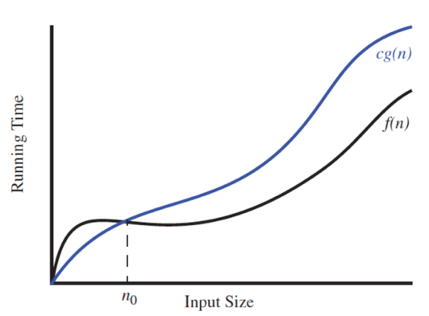

**Formal proof**

Given two functions f(n) and g(n), we say that f (n) is O(g(n)) if and only if there are positive constants c and n0 such that f(n)≤cg(n) ∀ n≥n0

**\*\*Note Constants C and n0 need to be independent (i.e. not dependent on N)**

**Example**

f(n) = 11n + 5 <= c*g(n)

Let’s try C = 12

11n + 5 <= 12n

f(n) = 11n + 5 <= c*g(n)

11n + 5 <= 12n

5 <= 12n - 11n

5<= n

f(n) = 11n + 5 <= c*g(n)

11n + 5 <= 12n

5 <= 12n - 11n

5<= n

**f(n)≤12g(n) ∀ n≥5**

We chose C = 12 but we could choose any real number >= 12 and any integer greater than or equal to 5 works for N

**Try this one yourself**

Show that 8*n* + 5 is *O*(*n*)

f(n) = 8*n* + 5

f(n)≤cg(n) ∀ n≥n0

Comparing two algorithms from different growth classes

We have two algorithms (ThreeSumA and ThreeSumB) that count the number of triples in a file of *N* integers that sums to 0 (ignoring integer overflow).

1. Estimate the Big O for each of these algorithms by looking at their code
2. Add simple java code to time the running time of both algorithms
3. Use the input files provided to run timing tests on both algorithms for each file, noting the results
4. Graph the results

*Note to run each file you need to first compile the java files to class files (use javac from the command line or your IDE) and then run each class with the different input files to time their performance. For example:

java ThreeSumA 1Kints.txt

java ThreeSumB 1Kints.txt

...and so on...and on.

[Practical 2 ThreeSumFile](https://csmoodle.ucd.ie/moodle/mod/resource/view.php?id=60584)

**Files supplied:**

* ThreeSumA.java
* ThreeSumB.java
* Input files of integers: 8ints, 1Kints, 4Kints, 8Kints, 16Kints, 32Kints

1. Use same code as last week for this:

|  |  |  |  |
| --- | --- | --- | --- |
| import java.lang.* | | | |
| This method returns the difference, measured in milliseconds, between the current time and midnight, January 1, 1970 UTC(coordinated universal time) | | | |
| Final long elapsedTime = System.currentTimeMillis() | | | |

Sample code you can use to time how your algorithm performs with different size input:

|  |
| --- |
| public static void main(String[] args)  {  final long startTime = System.currentTimeMillis();  myFunction(N):  final long elapsedTime = System.currentTimeMillis() - startTime;  System.out.println(“the time taken ” + elapsedTime);  } |

Converting to more readable time using something like below:

// long minutes = (milliseconds / 1000) / 60;

1. long minutes = TimeUnit.MILLISECONDS.toMinutes(milliseconds);
2. // long seconds = (milliseconds / 1000);
3. long seconds = TimeUnit.MILLISECONDS.toSeconds(milliseconds);
4. We expect to see something like the outputs below for both programs

|  |  |
| --- | --- |
| threeSumA | threeSumB |
| *\* java ThreeSumA 1Kints.txt*  *\* 70*  *\**  *\* java ThreeSumA 2Kints.txt*  *\* 528*  *\**  *\* java ThreeSumA 4Kints.txt*  *\* 4039*  *\**  *\* java ThreeSumA 8Kints.txt*  *\* 127867*  *\**  *\**  *\**  *\**  *\**  *\** | *\* java ThreeSumB 1Kints.txt*  *\* 70*  *\**  *\* java ThreeSumB 2Kints.txt*  *\* 528*  *\**  *\* java ThreeSumB 4Kints.txt*  *\* 4039*  *\**  *\* java ThreeSumB 8Kints.txt*  *\* 32074*  *\**  *\* java ThreeSumB 16Kints.txt*  *\* 255181*  *\**  *\* java ThreeSumB 32Kints.txt*  *\* 2052358* |